Note: The following procedures should be performed using a Windows PC. An addendum will be developed for Mac

Requisites: Complete Main Board, Control Board, PSU Board, Output Board and 1 Voice card.

School of hard knocks: If possible, have a third party check your chip orientation and insertion for 100% complete accuracy as one misplaced or disoriented chip can and will cause you great heart ache and pain. In addition, a single solder bridge and/or stray wire trimming can bring you to your knees upon power application…….Experience told me so!!!!!!

Getting Started Section
- Download and install the STLINK driver (STM32 ST-LINK Utility for STM32 MCUs): http://www.st.com/en/development-tools/stsw-link004.html

- Download and install the STM32 ST-LINK Utility (STM32 ST-LINK Utility for STM32 MCUs ): http://www.st.com/en/development-tools/stsw-link004.html

- Download, Unzip and save the Deckard’s Dream Boot Loader, Firmware and Preset Files to your PC (note where you saved it) This is a direct link to the zip file: http://www.deckardsdream.com/downloads/DD-FIRMWARE-REV1.0.zip

- Connect STLINK ribbon cable to DDRM’s Motherboard and connect STLINK USB cable to your PC and power up Deckard’s Dream. You should hear a device connected sound from your PC

- Start the STM32 ST-LINK Utility as you will use this to load the DD-BOOTLOADER-REV1.0.hex from the zip file you downloaded above in step #3 for the follow steps
STM32 ST-LINK Utility
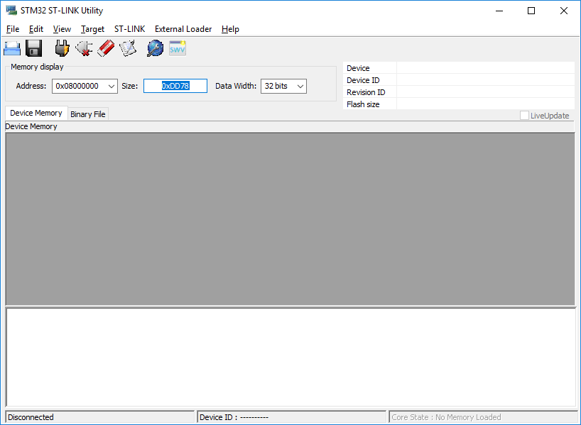

- Click on the Plug button 3rd from the left to connect the ST-LINK to the Deckard’s Dream ARM chip.
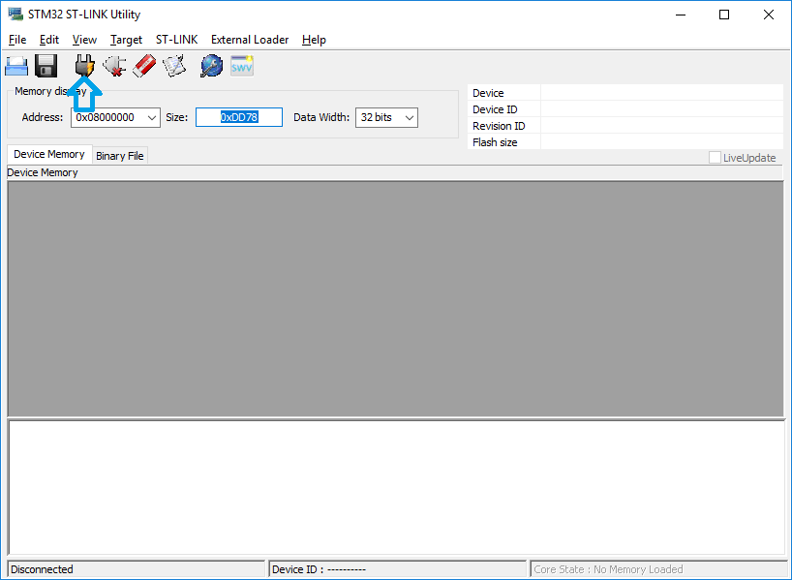
- You should see connection in the display window at the bottom of the screen
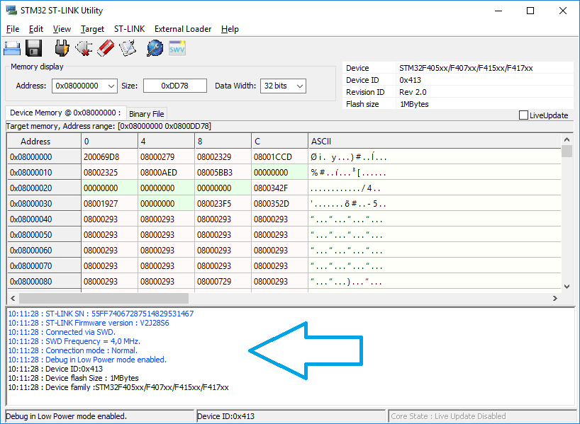

If not, see trouble shooting at the bottom of this guide (Coming Soon)

- Select the Target Menu so that you can Flash the Bootloader
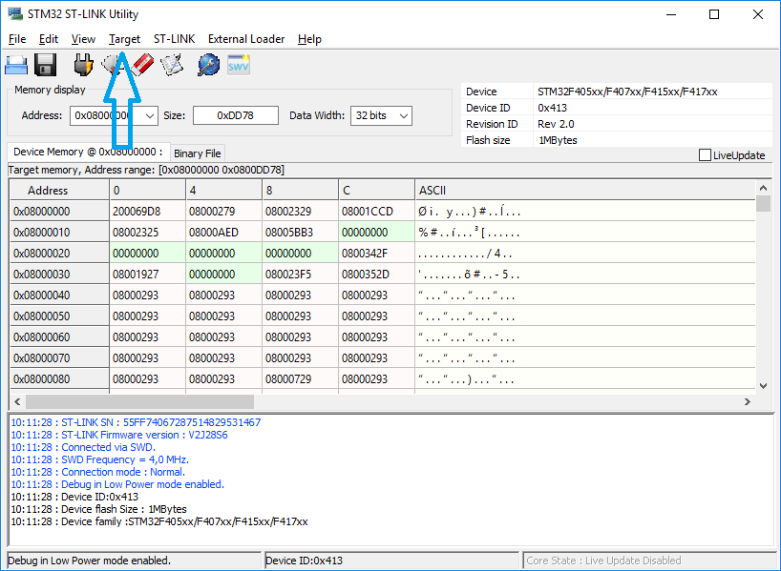

- Select Program & Verify
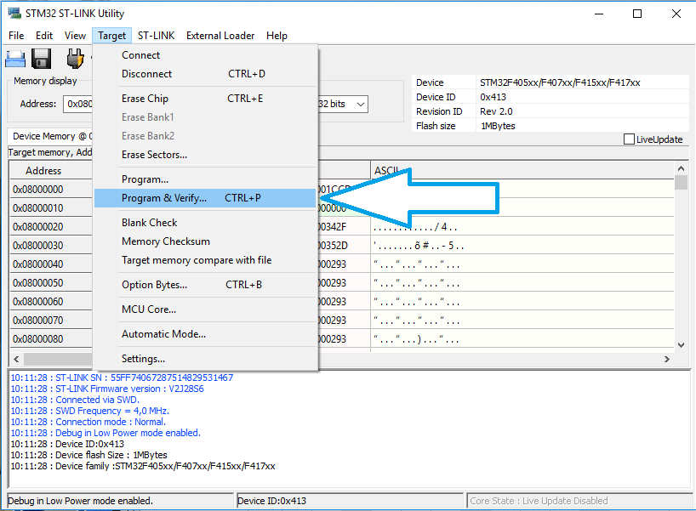

- After you select Program & Verify a file explorer screen will come up and you will need to select and open the DD-BOOTLOADER-REV1.0.hex you downloaded and saved to your PC in step #3 and then the following screen will appear
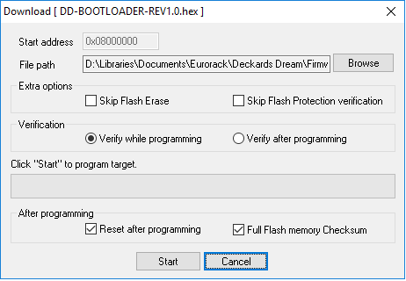
- You will see the file you selected. Leave all settings as they are defaulted and press the Start button.
Programming and Verification will begin and you will see the Progress bar and details in the bottom window. If all went well you will see results on the screen below. Your DDRM’s OLED may or may not display snow at the bottom, but usually does. Verification in green text is the result you are looking for

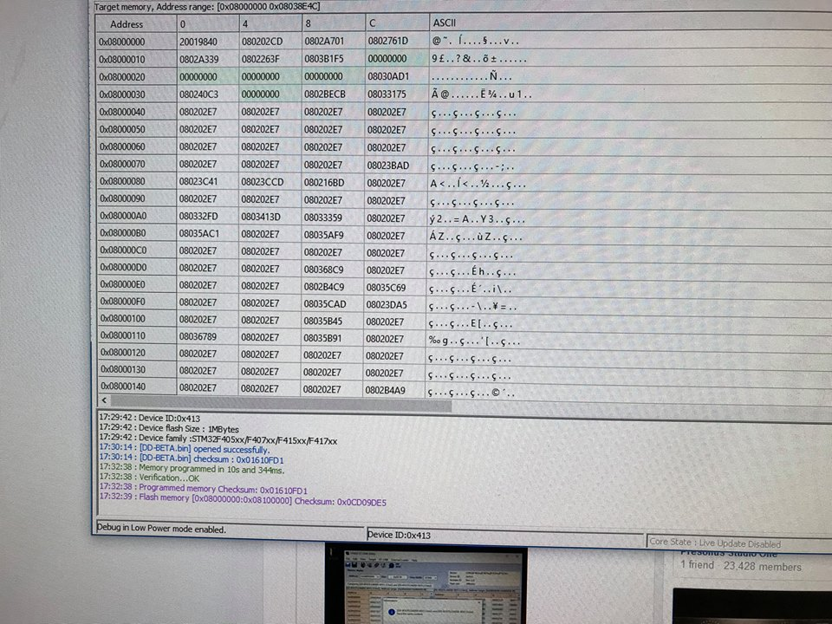

- Power down and remove the STLINK from the DDRM and PC.

- Power up the DDRM with ‘Shift’ key pressed and USB trident symbol should appear. (‘Shift’ key is the Lower-Left pushbutton beneath the OLED)

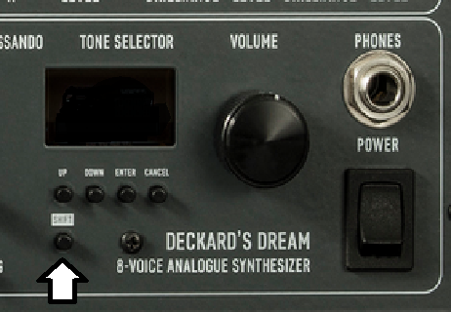

If all went well with the above steps, you will see the USB Trident on your display.
If not, see trouble shooting at the bottom of this guide (Coming Soon)

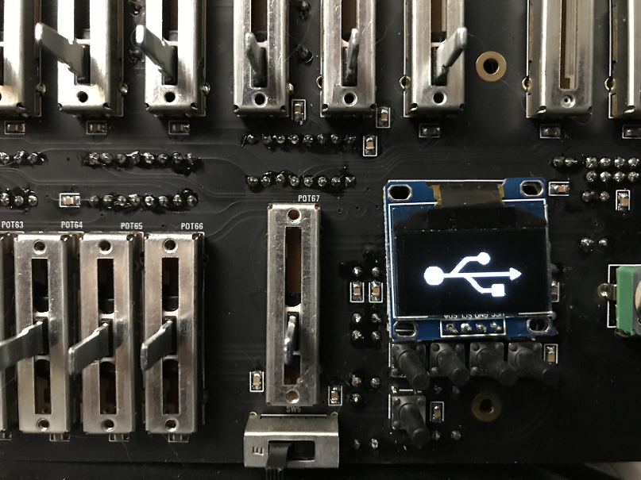
- Connect DDRM to the PC using a USB cable. Windows will automatically ask you to format the drive.
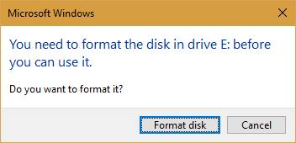

- Format using FAT (Default), uncheck ‘Quick Format’, and name the Volume label (DDRM, Etc.)
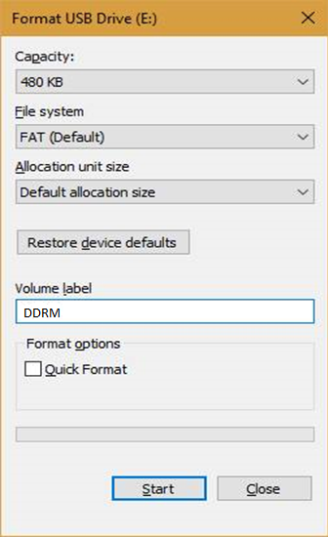

- Formatting complete…
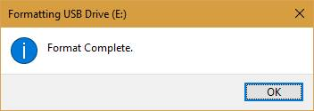

- Go to File explorer and check that Windows has recognized the new drive with the following size and space
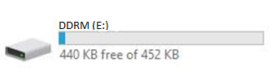

- Copy the Firmware and Patch file to the new drive.
Files DD-FIRMWARE-REV1.0.bin and dd_bank_f.p from the folder you save them to in step #3
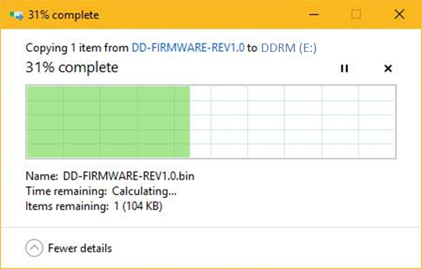

- Eject the drive using file explorer in windows and power down DDRM.
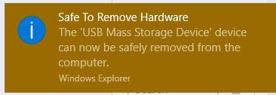

- Power up and the firmware should load.

PICTURE GOES HERE

DDRM Calibration
If any of the following do not go as expected, see trouble shooting section at the bottom of this guide (Coming Soon)

On Power Up you will default to Panel Mode – PNL will show in larger letters on the right middle of the display.

Note: The led on the output board indicates MIDI activity and will not light up unless you send some MIDI to it. To

- To begin configuration, press SHIFT (low left button) and CANCEL button (top row right most button)

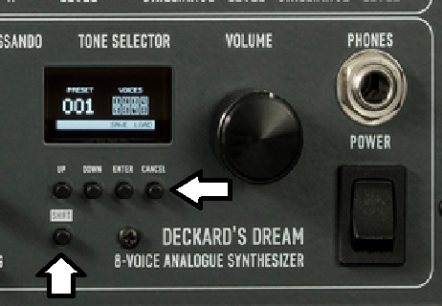

- Scroll down to voices and set the number of voice cards you have installed as the firmware defaults to 8.
PICTURE HERE
- If you have less than 8 then you will need to set the unit to unison mode as poly will not work with less than all 8
PICTURE HERE
- Go back up a level and scroll down to calibration and select it.
PICTURE HERE
- Set all detented sliders to their middle detent position select sliders and calibrate. This will happen in an instant and the menu will read DONE.
PICTURE HERE
- Hit the back button and go to the last item which is DEBUG and select. You can now step through each control on the control board to ensure that sliders read from 0 thought 255 and switches indicate on or off. Do this for all of the controls on the front panel. You can only go forward top to bottom left to right so if you miss one you will need to cycle all the way back around.
PICTURE HERE

- Note: the DDRM will play if its working regardless of front panel controls by just selecting a preset
PICTURE HERE
- Go back a level and then scroll to Oscillators and select. Hit enter to begin calibration and the unit will start at OSC 1A, then 1B and so on until all cards are calibrated as set above based on voice cards inserted
PICTURE HERE

- Once calibration is complete the display will read DONE.
PICTURE HERE

- Hit the back button until you are in panel mode
PICTURE HERE

TRUBLE SHOOTING SECTION

To be developed sooner or later depending on whim and fancy…..HEE HEE HEE

In the mean time leverage the following resources.
www.deckardsdream.com/build - OFFICIAL SITE

You can find help on Muffwiggler here: https://www.muffwiggler.com/forum/viewtopic.php?t=189382

There is also a wiki here: https://www.dsl-man.de/display/DDRM/

Facebook Group: https://www.facebook.com/groups/deckardsdream/ (Private you will need to join or be invited)

